UNLOCKING INSIGHTS INTO THE GLOBAL AIR TRANSPORTATION NETWORK WITH TABLAEU

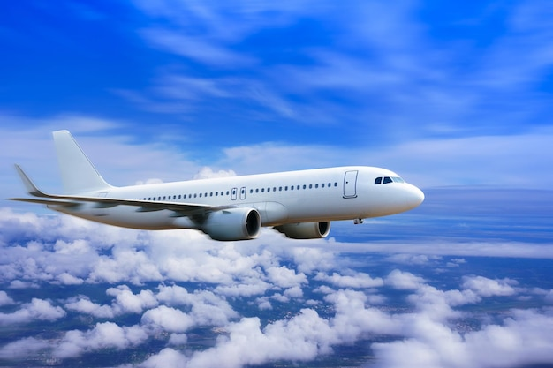

INTRODUCTION

**OVERVIEW**

**Air travel is a form of travel in vehicles such as airplanes, jet aircraft, helicopters, hot air balloons, blimps, gliders, hang gliders, parachutes, or anything else that can sustain flight. Use of air travel has greatly increased in recent decades-worldwide it doubled between the mid-1980s and the year 2000.**

**PURPOSE**

**Aviation is the safest and fastest means of transportation. Overcoming oceans and borders to connect people and support economic growth. By spurring tourism and trade, air trade, air travel contributes to increasing consumer benefits and choices, creating job, and generating numerous socioeconomic benefits. Most companies use air transport to market goods and products internationally or to deliver samples and documents related to foreign trade operations.**

**PROBLEM DEFINITION & DESIGN THINKING**

Brainstorm;

**The inflatable dartboard is easy to transport and works well with Velcro darts. Try this brainstorm method; the contradictory innovation-also known as the waterproof Teabag method. The contradictory innovation brainstorm method is lateral thinking in a action.**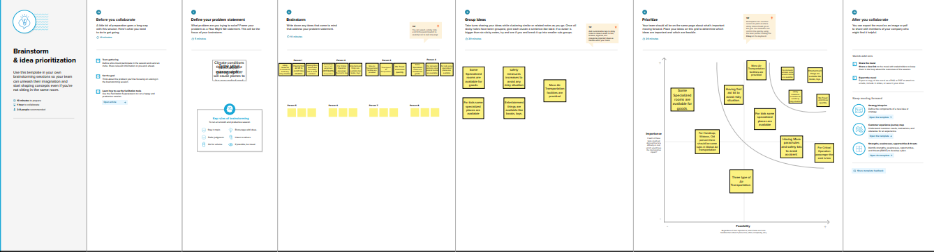

**EMPATHY:**

**By synthesizing and visualizing the data from user research and interviews, empathy maps can help**

**Identify key insights and themes. This Global Air Transportation Network dataset is a comprehensive collection of information on airports, airlines their routes.**

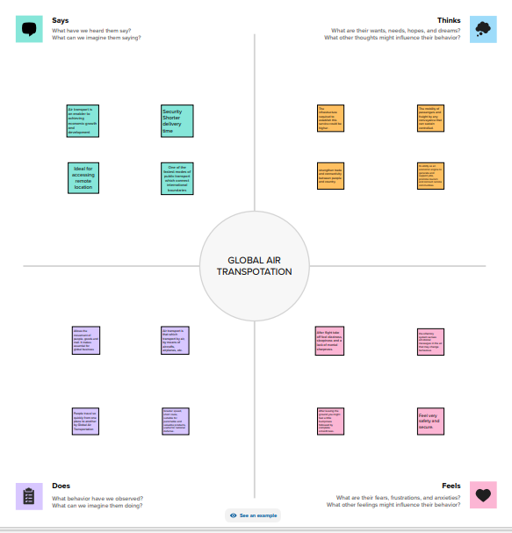

**RESULT**

**Define problem**

* **Air travel is the riskiest mode of transport, since there can be considerable losses to goods, customer and crews as a result of a minor crash.**
* **Compared to other means of travel, the risk of collisions are higher. These factors contributed to the challenges faced by the sector, including the struggle of airlines to survive and the high operating costs.**

**DATA COLLECTION AND**

**EXTRACION FROM**

* **Data collection is the process of gathering and measuring information on variables of interest in a established systematic fashion that enables one to answer stated research question, test hypotheses, and evaluate outcome and generate insights from the data.**
* **This Global Air Transportation Network dataset is a comprehensive collection of information on air ports, air line and their routes. This dataset has been complied through meticulous labor by research all over the world to give you a comprehensive detail into air transportation.**

**DATA preparation**

* **The right data, harnessed in the right way, can deliver actionable insights that are truly transformative for decision-making, efficiency and smooth passenger-focused delivery of services.**
* **Jim Peters, Chief Technology Officer at SITA, reveals how big data is beginning to deliver real value in the air transport industry.**

* **Investment in BI is critical if the maximum value is to be obtained from the vast volumes of data increasingly available to airport and airline management.**

**DATA VISUALIZATION**

* **The task of visualizing data becomes more challenging as the size and complexity of the data increase.**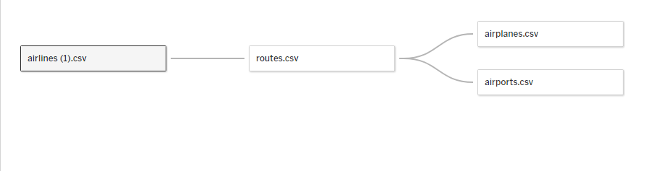
* **Specifically, for air transportation network, large data set or big data contain temporal and spatial information that can facilitate decision-making during disruptions. This research explores the interpretation and visualization of time- dependent flight and weather data.**

**DASHBOARD**

* **A global operations dashboard provides a high-level overview of an airline’s current operations. Typically it shows currently operated flights enriched with the essential key performance indicators.**
* **The dashboard aims to provide awareness and the overall status of the entire operations. There’s no intention to go into details.**
* **If an airline only operated in specific parts of the world, it doesn’t show the entire world.**

**STORY**

* **High speed, air is the type of freight capable of travelling long distance in the short periods of time.**
* **Air transportation was slow to take off after the Wright Brothers breakthrough at Kitty Hawk in 1903. More than decade passed before the first faltering Efforts to launch scheduled flight with a paying passengers hopped across the bay separating Tampa and St. Petersburg, Florid**
* **The importance of air transport lies in its ability as an economic engine to generate and support jobs, strengthen trade and connectivity between people and countries, promote tourism, and connect remote continuities.**

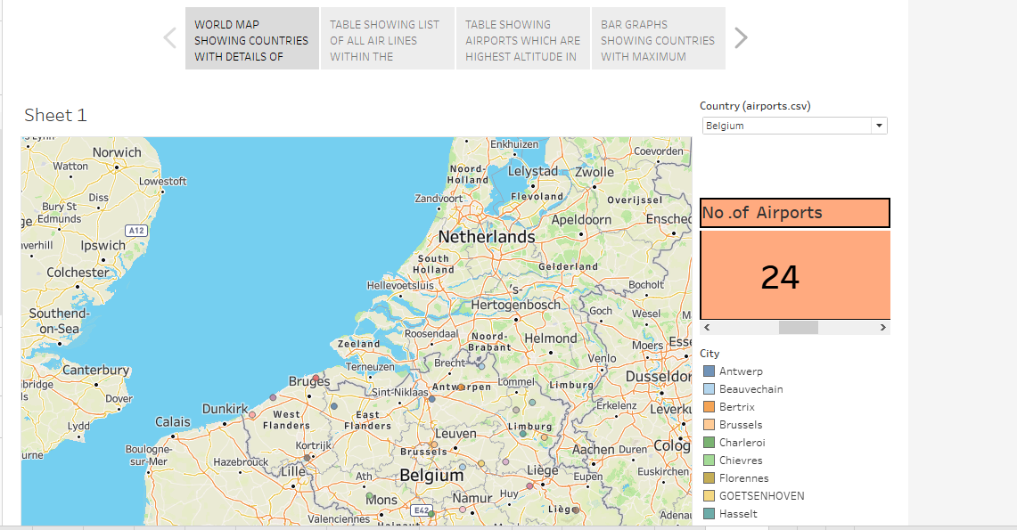

**PERFORMANCE TESTING**

* **Air transport performance can be defined as the ability to climb, accelerate, or maneuver in order to successfully accomplish its mission.**
* **Obviously expected performance specifications must be an integral part of the design process of an aircraft**

**.**

* **It is also certain that actual performance characteristics will not always be the same as those predicted by the designer.**
* **Determination of aircraft performance is dependent upon our knowledge of fundamentals is several different scientific disciplines.**
* **Aircraft performance refers to the ability of airplanes and helicopters to accomplish certain useful things. It is an important consideration when designing and testing aircraft, to ensure the aircraft can be operates in an efficient and economic manner.**

**PUBLISHING**

* **Air Transport publication Ltd (ATD) brings authoritative and independent coverage lot the aviation market through its popular print magazines, directories and newsletter. ATP was founded in1996 with the Aircraft Maintenance and Engineering Directory.**
* **Air transportation world (ATW) is an online and print trade publication covering the global air transportation industry. It is owned by INFORMA and is a sister publication to Aviation week, the Aviation Daily and MRO Digest, which are all part of the Aviation Week Network Group.**

**PROJECT DEMONSTRATION AND**

**DOCUMENT**

**AIR TRANSPORTATION**

* **Air transport is an aircraft design for transporting passengers and freight from one location to another in the air using airplanes, jets, rockets helicopters, and drones,**
* **Each these type of air transport has a unique way of achieving speed and the sustainability of it voyage.**
* **However there are other types of air transport which may or may not be used for conveying, but could be used for recreational purposes.**

**ADVANTAGES AND DISADVATAGES**

**Advantages**

* **HIGH SPEED**
* **COMFORTABLE AND QUICK SERVICES**
* **NO INVESTMENT IN CONSTRUCTION OF TRACK**
* **NO PHYSICAL BARRIERS**
* **EASY ACCESS**
* **EMERGENCY SERVICES**
* **QUICK CLEARANCE**
* **MOST SUITABLE FOR CARRYING LIGHT GOODS OF HIGH VALUE**
* **NATIONAL DEFENCE**
* **SPACE EXPOLRATION**

**DISADVANTAGES**

* **VERY COSTLY**
* **SMALL CARRYING CAPACITY**
* **UNCERTAIN AND UNRELIABLE**
* **BREAKDOWNS AND ACCIDENT**
* **LARGE INVERSTMENT**
* **SPECIALISED SKILL**
* **UNSUITABLE FOR CHEAP AND BULKY GOODS**
* **LEGAL RESTRICTIONS**

**CONCLUSION**

**The air transport industry is not only a vital engine of global socio-economic growth but is also of vital importance as a catalyst for economic development in most countries and for many regions within each country. Its importance arises not only from its ability to facilitate the movement of people but also its ability to expedite the movement of goods.**

**FUTURE SCOPE**

**The roadmap outlined significant benchmarks to achieve the goal of marking India the best-performing centre for aviation by 2040, in addition to expanding the country’s aviation industry. The aviation market is anticipated to expand quickly between 2022 and 2029 throughout the anticipated time period.**

**Emerging technologies are reshaping with robotics, artificial intelligence, the internet of things, unmanned aircraft systems and the push for hybrid and electric airplanes just to name a few.**

**APPENDIX**

**Source code:**

**DATASET:**

<https://drive.google.com/drive/folders/1RJnbcGxvIVulM3fkZH1Wz3IbLDP2RjY?usp=share> link

|  |  |  |  |  |
| --- | --- | --- | --- | --- |
| DASHBOARD 1   |  | | --- | |  | |  |  |  |
|  | | |

https://public.tableau.com/views/Team13Dashboard1/Dashboard1?:language=en-US&publish=yes&:display_count=n&:origin=viz_share_link

**DASHBOARD 2**

|  |  |  |  |  |
| --- | --- | --- | --- | --- |
| |  | | --- | |  | |  |  |  |
|  | | |

<https://public.tableau.com/views/Team13Dashboard2/Dashboard2?:language=en-US&publish=yes&:display_count=n&:origin=viz_share_link>

DASHBOARD 3

|  |  |  |  |  |
| --- | --- | --- | --- | --- |
| |  | | --- | |  | |  |  |  |
| |  | | --- | | https://mail.google.com/mail/u/0/images/cleardot.gif | | | |

<https://public.tableau.com/views/Team13Dashboard3/Dashboard3?:language=en-US&publish=yes&:display_count=n&:origin=viz_share_link>

DASHBOARD 4

|  |  |  |  |
| --- | --- | --- | --- |
|  |  |  |  |
| |  | | --- | | https://mail.google.com/mail/u/0/images/cleardot.gif | | | |

<https://public.tableau.com/views/Team13Dashboard_16958009027030/Dashboard4?:language=en-US&publish=yes&:display_count=n&:origin=viz_share_link>

**STORY**

|  |  |  |  |  |
| --- | --- | --- | --- | --- |
| |  | | --- | |  | |  |  |  |
|  | | |

<https://public.tableau.com/views/Team13Story/Story1?:language=en-US&publish=yes&:display_count=n&:origin=viz_share_link>